**Title: Smart Farm System Final Report**

Contents

Abstract 2

Introduction and background 2

Materials/Tools used 2

Method/Logic of the system 3

Results 4

Discussion and conclusion 5

Project plan (Next phases) 5

Full autonomous recommending systems; 5

A full smart farm system; 5

Project evaluation: 5

Project success 5

Unexpected events 5

Lessons learned; 6

# Abstract

Internet of Things" (IoT) is a technology that enables things (devices) to communicate and connect with each other. This is helpful in changing the patterns and processes in both industry and agriculture towards higher efficiency, accuracy and effectiveness. A system is proposed which describes the smart farming crop recommendation system in order to improve the production process for farmers. Smart farming consists of two main parts which are a sensor system and a server system. Sensor system consists of a set of tools to obtain the sensed values. Server system involves a graph for analysis and recording the sensed data. An Arduino board is programmed for sensing and the controlling system. Programming for controlling the system is done in C language. The sensed values from the different sensors are viewed on a ThingSpeak server which are then sent IFTTT server for triggering an email notification to the farmer. Results are maintained can be exported from ThingSpeak server and then kept as a database in excel sheet and the graphical representation of the same is obtained. Looking on to results obtained from the sensor system, the server is activated using the MATLAB code to react on the data. An increase in product quality and quantity is achieved by following the proper decision-making process.

# Introduction and background

The current situation in Malawian agricultural sector depicts that most farmers do not follow a proper procedure to choose crops to grow in a particular season as a result crop yield keeps on decreasing each year. This is so mainly because most farmers do not have access to information on crops, do not have automated systems that can help them on their farm. Through this paper, we introduce a concept for smart farming crop recommendation system which utilizes wireless web technology for temperature and moisture (humidity) detection in the soil and surrounding area which plays a very important role in helping Malawian farmers. We introduce an Arduino based Wi-Fi system that sends the results to a web server and after analysis of the results after 2-3 weeks, the results are automatically emailed to the farmer depending on the conditions of the farm. Our system will be able to help the farmers who wants to improve their yield by following and using the recommendation analysis of real time data from their farm.

# Materials/Tools used

* 1* Arduino Board
  + The main circuit board
* 1* DHT11 Humidity and Temperature Sensor
  + Digital Humidity and Temperature sensor is a temperature sensor as well as a humidity sensor. It constitutes two different parts which are the capacitive humidity sensor and a thermistor.
* 1* Breadboard
* ESP8266-01 Wi-Fi Module
  + The ESP8266 ESP-01 is a Wi-Fi module that allows microcontrollers access to a Wi-Fi network.
* Male and Female Jumper wires
  + For connecting the components together
* 1*power bank (batteries)
  + To supply the Arduino and sensors power
* Soil moisture sensor
  + Soil Moisture sensor is meant to measure the volumetric content of water inside the soil and serves us with the moisture level at the output. The sensor can be used in both analog and digital mode since it is equipped with both analog and digital output.

# Method/Logic of the system

Connect the above components as shown in the below circuit diagram:

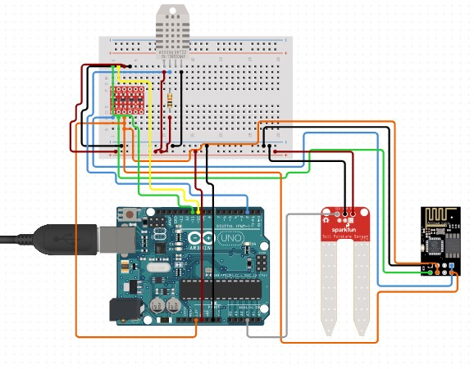

After setting up and connecting the components together, connect the Arduino to a computer and change, server channel API, the Wi-Fi SSID and password in the Arduino IDE and upload the code to the Arduino but be sure to test it that it can connect, send and receive data through the configured network. On [https://thingspeak.com,](https://thingspeak.com/) create an account and create a new channel on the server on which you will receive the data sent by the Arduino. The data will be analyzed by an embedded MATLAB API which compiles the codes written to it. Still on thingSpeak server, the reactor is like alarm which is set to run the MATLAB code programmed to analyze the data once in every weekend to calculate average temperature, humidity and soil moisture and also to maximize accuracy of the data. The results of the analysis are sent to another *thingSpeak* channel which records the average the different categories of the test analysis. Since the most crops between 18 degrees Celsius and 20 degrees Celsius, a reactor on the server triggers a ThingHttp on the server which also triggers another module from [https://ifttt.com](https://ifttt.com/) server, a *IFTTT* (IF-ThisThen-That) which is used to trigger an email notification to be sent to the farmer when the temperature in greater than or equal to 18 degrees Celsius. The email is the only thing the farmer will be looking at, no technical setup will be done by the farmer for simplicity of the system. The email sent to the farmer consists of the links t[o https://thingspeak.com](https://thingspeak.com/) analysis graphs of the farmer and a link to the recommendation document from which he/she can use to decide what crop to grow in that particular season depending on what the system collected from the farm.

# Results

Our goal was to make a recommendation system for farmers in Malawi, as per planned we managed to provide the system we intended to. As a group we used the build measure learn approach and the humancentric approach to get the results, in the first place we did a *user*research to see if our system was indeed a solution to the problem that Malawi farmers are facing, the **results** where positive and we continued to the next stage. After that we asked *user**feedback*from our end users to see if our system is what they expected and a good technology for Malawi as a nation, here is the user feedback;

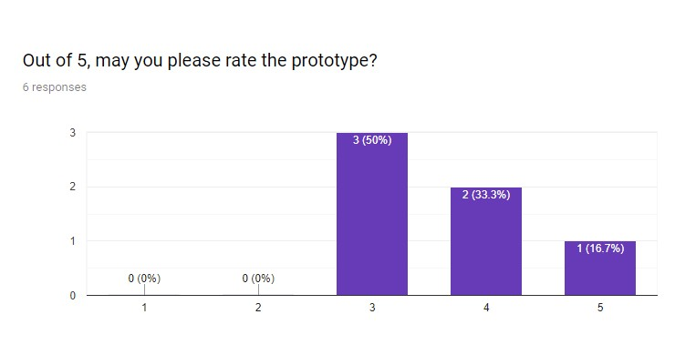

In a statement; Based on the end user results and system proper functionality, our system specifically the Arduino based technology system we used is a solution to the recommendation problems famers have at the present. Malawi needs an appropriate technology because Malawi is a developing country with a lot of people not financially stable including famers; a cheap and a good technology to still help the country is our system.

# Discussion and conclusion

From the survey we conducted we can finally conclude that Malawi farmers have indeed difficulties to choose the next crop to grow, this has given us an opportunity as human centered interaction students to use the Arduino based technology system to give them a solution.

As a conclusion we would say as a group we have managed to provide the solution that Malawi farmers need. This humancentric and appropriate technology will have a great impact towards Malawi as whole.

The idea is that when famers know what is best for them to grow there is a high possibility that the yields will be high, so in this situation food cannot be scarce, generally we can say the economic growth and good living standards can be improved through our system.

This is a solution for a lot of problems if we see it from the above perspective.

# Project plan (Next phases)

Every project is in phases as it is with our project too; in the next phases we have planned to implement the following;

## Full autonomous recommending system;

Though we have managed to give the recommendations to the famers but still more our system is not fully automatic, farmers are supposed to manually check the humidity and temperature and see the crops favorable in those ranges of readings manually, in the next phase we want our system to automatically show the best crops for that area as per the readings from the implanted sensors.

## A full smart farm system;

Our system is a smart system but only implements a few areas of the full smart system, in this phase we only focused on the recommendation part but in the next phases we want to make systems to monitor when the plants have been grown up to harvesting satges.

# Project evaluation:

## Project success

• As per planed we have managed to give out what we wanted to achieve in the first phase that is a recommendation system for the farmers that’s in the within required time

## Unexpected events

* We did not manage to give a full smart system because of time limitations, but given enough time we can provide a full autonomous system to Malawi famers.
* During rainy days we had difficulties to collect data from the plants and environment. We found the solution on the last day where we covered our sensors in an interesting way, but in the cases of fully implementing the system we then

can have well organized and arranged sensors for good data collection and all weather friendly.

## Lessons learned;

* Putting humans at the center for your product developments or solution is the way to go because human know better what their problems are and solutions can be found through a clear understanding of their problems.
* Doing anything on a planned schedule is a good tactic for group projects like these. Considering each and every individual in the project team is relatively important for the overall team performance.

**References**

<https://create.arduino.cc/projecthub/AhmedAzouz/rory-the-robot-plant-f7e74b?ref=tag&ref_id=plants&offset=0>

<https://www.instructables.com/id/Automated-FARM-Arduino-fanlightswater-Pump/>

<https://www.youtube.com/watch?v=2cjufbgOBYo&t=499s>

https://www.youtube.com/watch?v=4XEe0HY0j6k&t=194s